## **GENERAL OVERVIEW**

* Describe what your project is about.

The big goal of this project is giving a content preview of the Humboldt Forum Foyer before its full opening, and we solve the problem by offering the visitors an AR application. The most important part of the project is the immersive interaction experience, which raises the dimension of the traditional one. I feel particularly excited during this world pandemic period for its high relevance and usability. I think it might be interesting to integrate this situation into the project.

* Describe why this project is relevant to its medium.

I want to compare AR and VR in this specific case. All of those three means could reach the goal of introducing the contents before full opening. AR immerses the audience to the reality, rather than immerses the visitor in a detach way as VR does. Through AR, visitors could walk in the actual space and go up and down to the specific room and “see” the objects, which is a more contextualized experience. Also, in this digital era when everyone has a phone, AR is easy for reaching the mass public.

* Describe the learning experience that you want to suggest in your audience

People want to experience the things that interest them. So we are going to create a customized learning experience which could raise people’s interests in a playful way. The 3D objects might not appear at the location they would on display but scatter around the Foyer for visitors to find, which could be like a treasure hunt or Pokemon game. The information description of the object would appear by clicking it. And people should find the right niches to put the object back in. The whole idea is to let people engage more in learning about the objects and the overall distribution of the Foyer.

* Are there any unusual aspects?

Something that other projects in the same field don't have to take care of, but that you're experimenting with for the first time? This part is meant to show that you are not afraid to push boundaries of what exists, but that you are also aware of what you are doing.

Design Overview

Context

We will use the foyer as the background for this augmented reality experience whether it is using a Cinema 4D file as a virtual background or actually applying the application in the real foyer. We have not decided on the art objects for the project. But we will choose a few highlights from each floor, since we are doing the recognition of different floors and provide key pictures and artworks for each floor so the viewers will have an introductory idea of what exhibition is happening on which floor.

Interaction

The audience will walk around the foyer and point their phone camera to different floors, so artwork or exhibit room number will pop up when the camera focuses on different key recognition at different levels, and a user could learn more about the future exhibit or sculptures from the main foyer. It is like a quick guide or virtual 3d map. So one will know which floor they want to visit or to explore when the place is fully opened.

Flow

The user will first see the Landing page then a quick swipe will lead the users to a guide (steps to follow) of the app including how to use this tool (or app). The next page will be the last introductory page which suggests a few tips, including opening the camera permission, etc. or include a rough map of this forum. Then the user enters the main camera AR experience. User will aim their camera on different floors so floor name or exhibition name will pop up. Then the user could click on these icon/ buttons. In these specific rooms and floors, the user will discover the key 3d art objects from each exhibition in the foyer.

Interface

The interface uses a mix of swipes, and clicks.

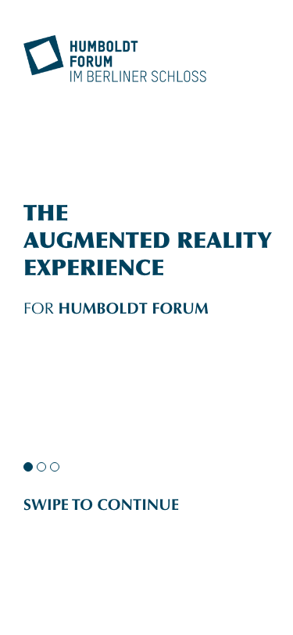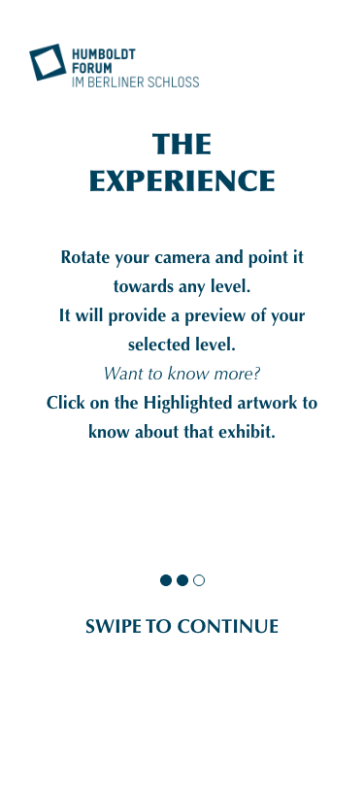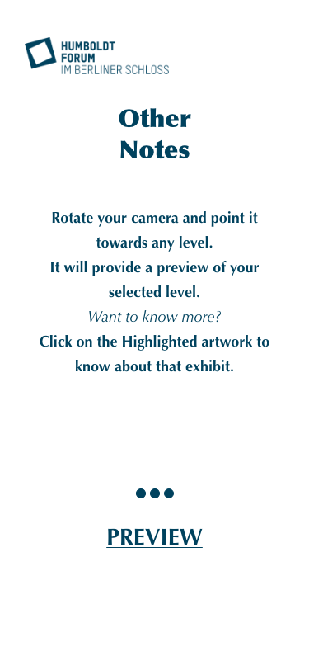

The introductory interfaces.

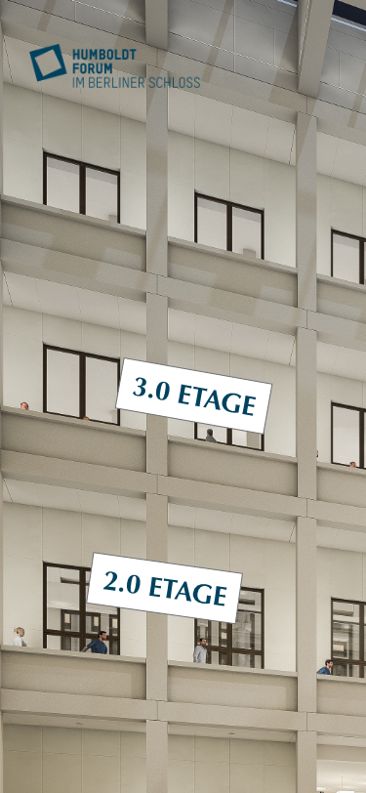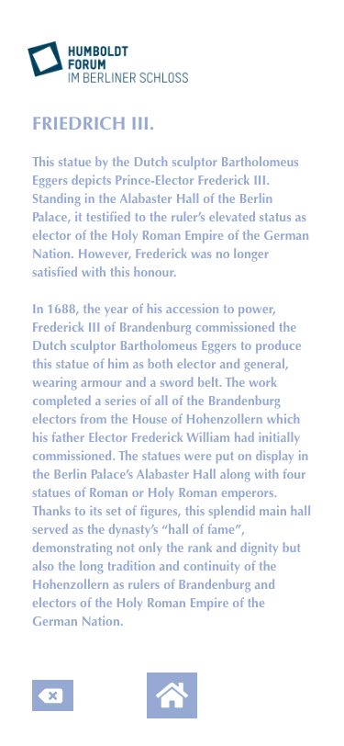

From the main camera view to the specific artworks and its texts.

Media assets.

Some of the photos from the official website and 3d objects files for selected artworks. And maybe the cinema 4d file for the foyer.

**EXPERIENCE OVERVIEW**

Our audience will be able to start immersing themselves with our interactive application from any spot in the foyer. There is no specific starting point, they can simply open the app anytime in the main foyer area and point their camera to the different floors in order to explore all of the places to see in the museum. Upon arrival in the foyer, there will be many spots where the user can scan a QR code which will allow for the download of the foyer AR application onto their cell phone. Their experience can evolve throughout the foyer as they choose to explore the different possibilities of all the wings of the museums and look at information about all of the different highlighted objects. Their experience would ideally conclude once they reach the exhibit and they can look at the real versions of the exhibitions rather than the digital reproductions of the highlighted objects, but will be invited to reopen their AR apps once they return back to the main foyer. The main aspects to mention about our application are the first instruction slides that will first appear with the main opening of the app. Following, will be the opening of the AR aspect where the user can scan the different levels and hallways that split from the forum and from there, they can click on which gallery to preview. From this preview, they can access an overview of information about the gallery as well as learn about the highlighted object that best represents the philosophy of this part of the museum. A separate slide can be accessed which will provide more in depth information about such highlighted objects if the user wishes to learn more.

As they move through the scene, the audience member will be in awe as they scan all the possibilities of the museum. It will allow for them not only to learn which every part of the museum can offer, but also allow them to develop a strategy in their head for how to visit every part of the museum that day. Our system starts will small, technical slides which display the information that users must first understand in order to fully interact with our application, then once all of the information slides are read, they will be able to freely use their device to scan and look around the entire forum. This moment will allow for them to be able to process all of the different ideas the museum has to offer as well as give them a sneak peak of the information they shall later come across in their museum exploration period. I think the inclusion of the highlighted objects once the user chooses to select a specific wing of the museum will allow the interactor to more easily get a feel for which part of the museum fits their museum exploration needs without actually going to the gallery first.

**CONCLUSION**

#### Our project is important because it allows for the smooth addition of more technical aspects of AR and digitalization of museums to be added to a real life space. This addition of the AR experience will not impede on any aspect of the museum experience, but will simply expand the possibilities of what can be done with the space of the foyer. This is essential because we are using the benefits of AR to streamline the experience of a museum visitor and setting the example for all museums that technologization can both assist with visitor’s comprehension of the space as well as make their experience just that more enjoyable. Along with our development of this application, we must focus on applying just as much information as we need to guide our audience in their own museum excursion without overloading them with too much information as to confuse their experience. With the conclusion of our project, it will present the perfect articulation of virtual and physical space and how the application of augmented reality can coexist with a social space such as the foyer.